EXERCISE 1 : MOCKING AND STUBBING

Scenario: You need to test a service that depends on an external API. Use Mockito to mock the
external API and stub its methods.
MyServiceTest.java:
package com.example;

import static org.mockito.Mockito.*;
import org.junit.jupiter.api.Test;
import static org.junit.jupiter.api.Assertions.*;

public class MyServiceTest {
@Test
public void testExternalApi() {
ExternalApi mockApi = mock(ExternalApi.class);
when(mockApi.getData()).thenReturn("Mock Data");

MyService service = new MyService(mockApi);
String result = service.fetchData();

// Use System.err to force console output
System.out.println("Fetched result: " + result);

assertEquals("Mock Data", result);
}

}
Pom.xml(Mockito-demo):
<project xmlns="http://maven.apache.org/POM/4.0.0"
xmlns:xsi="http://www.w3.org/2001/XMLSchema-instance"
xsi:schemaLocation="http://maven.apache.org/POM/4.0.0 http://maven.apache.org/xsd/maven-4.0.0.xsd">
<modelVersion>4.0.0</modelVersion>
<groupId>com.example</groupId>
<artifactId>mockito-demo</artifactId>
<version>1.0-SNAPSHOT</version>

<dependencies>
<dependency>
<groupId>org.junit.jupiter</groupId>
<artifactId>junit-jupiter</artifactId>
<version>5.10.0</version>
<scope>test</scope>
</dependency>
<dependency>
<groupId>org.mockito</groupId>
<artifactId>mockito-core</artifactId>
<version>5.11.0</version>
<scope>test</scope>
</dependency>
</dependencies>

<build>
<plugins>
<plugin>
<groupId>org.apache.maven.plugins</groupId>
<artifactId>maven-surefire-plugin</artifactId>
<version>3.2.5</version>
</plugin>
</plugins>
</build>
</project>

MyService.java:
package com.example;

public class MyService {
private final ExternalApi externalApi;

public MyService(ExternalApi externalApi) {
this.externalApi = externalApi;
}

public String fetchData() {
return externalApi.getData();
}
}
OUPUT:
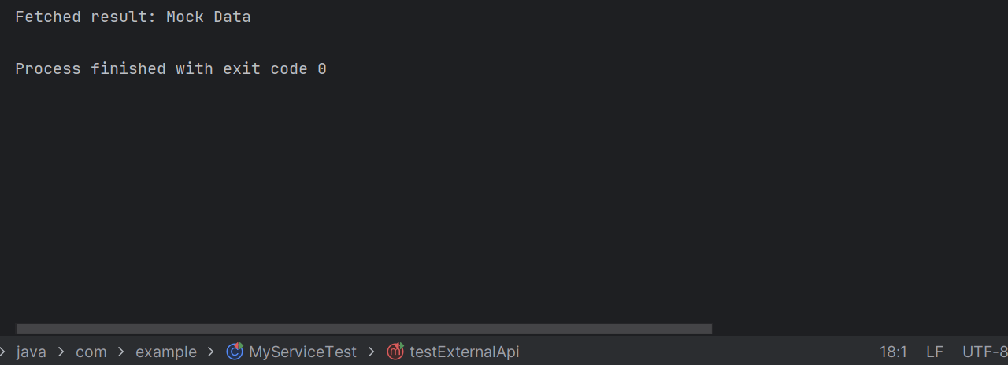
EXERCISE 2: VERIFYING INTERACTIONS

Scenario: You need to ensure that a method is called with specific arguments.
MyServiceTest.java:
package com.example;

import org.junit.jupiter.api.Test;
import static org.mockito.Mockito.*;

public class MyServiceTest {

@Test
public void testVerifyInteraction() {
System.out.println("Starting test for verifying interaction...");

ExternalApi mockApi = mock(ExternalApi.class);
MyService service = new MyService(mockApi);

service.fetchData();

verify(mockApi).getData();

System.out.println("Test finished. Interaction verified.");
}
}
Pom.xml():
<project xmlns="http://maven.apache.org/POM/4.0.0"
xmlns:xsi="http://www.w3.org/2001/XMLSchema-instance"
xsi:schemaLocation="http://maven.apache.org/POM/4.0.0 http://maven.apache.org/xsd/maven-4.0.0.xsd">
<modelVersion>4.0.0</modelVersion>

<groupId>com.example</groupId>
<artifactId>MockitoVerifyInteractionExample</artifactId>
<version>1.0-SNAPSHOT</version>

<dependencies>
<dependency>
<groupId>org.junit.jupiter</groupId>
<artifactId>junit-jupiter</artifactId>
<scope>test</scope>
</dependency>

<dependency>
<groupId>org.mockito</groupId>
<artifactId>mockito-core</artifactId>
<version>5.11.0</version>
<scope>test</scope>
</dependency>

<dependency>
<groupId>org.junit.platform</groupId>
<artifactId>junit-platform-launcher</artifactId>
<version>1.10.2</version>
<scope>test</scope>
</dependency>
</dependencies>

<dependencyManagement>
<dependencies>
<dependency>
<groupId>org.junit</groupId>
<artifactId>junit-bom</artifactId>
<version>5.10.2</version>
<type>pom</type>
<scope>import</scope>
</dependency>
</dependencies>
</dependencyManagement>

<build>
<plugins>
<plugin>
<groupId>org.apache.maven.plugins</groupId>
<artifactId>maven-surefire-plugin</artifactId>
<version>3.2.5</version>
</plugin>
</plugins>
</build>
</project>

MyService.java:
package com.example;

public class MyService {
private final ExternalApi externalApi;

public MyService(ExternalApi externalApi) {
this.externalApi = externalApi;
}

public void fetchData() {
System.out.println("Calling external API from MyService...");
externalApi.getData();
}
}
OUPUT:
